Bahria University,

Karachi Campus



LAB EXPERIMENT NO.

13

LIST OF TASKS

|  |  |
| --- | --- |
| TASK NO | OBJECTIVE |
| 01 | Simplify the following function using K-Map in: Sum of Product. (SOP) Product of sum (POS). 𝐹 (𝐴, 𝐵, 𝐶, 𝐷) = ∑(0, 1, 2, 5, 8, 9 ,10) |
| 02 | Simplify the Boolean Function using K-Map: 𝐹 (𝐴, 𝐵, 𝐶, 𝐷) = ∑(1, 3, 7, 11, 15)  Which has the don’t care conditions: 𝐷 (𝐴, 𝐵, 𝐶, 𝐷) = ∑(0, 2, 5) |
| 03 | Simplify the Boolean Function using K-Map: 𝐹 = 𝐸8 (Hex) |

Submitted On:

____________

(Date: DD/MM/YY)

**Task No. 1: Simplify the following function using K-Map in**

**Sum of Product. (SOP) Product of sum. (POS)**

**𝐹 (𝐴, 𝐵, 𝐶, 𝐷) = ∑(0, 1, 2, 5, 8, 9 ,10)**

**Verify Boolean function ‘F’ before and after K-Map simplification using truth table and design circuit on hardware / software.**

**Solution: K-MAP**

|  |  |  |  |  |
| --- | --- | --- | --- | --- |
|  | **C’. D’** | **C’. D** | **C. D** | **C. D’** |
| **A’.B’** | **1** | **1** | **0** | **1** |
| **A’.B** | **0** | **1** | **0** | **0** |
| **A.B** | **0** | **0** | **0** | **0** |
| **A.B’** | **1** | **1** | **0** | **1** |

**SUM OF PRODUCT**

|  |  |
| --- | --- |
| Groups | |
| (0,1,8,9) | B’.C’ |
| (0,2,8,10) | B’.D’ |
| (1,5) | A’.C’.D |

**F = B'C' + B'D' + A'C'D**

**PRODUCT OF SUM**

|  |  |
| --- | --- |
| Groups | |
| (3,7,11,15) | C.D |
| (4,6,12,14) | B.D |
| (12,13,14,15) | A.B |

**F = C.D + B.D + A.B**

|  |  |  |
| --- | --- | --- |
| **F** | **=** | **C.D + B.D + A.B** |

**F = (C' + D') (B' + D) (A' + B')**

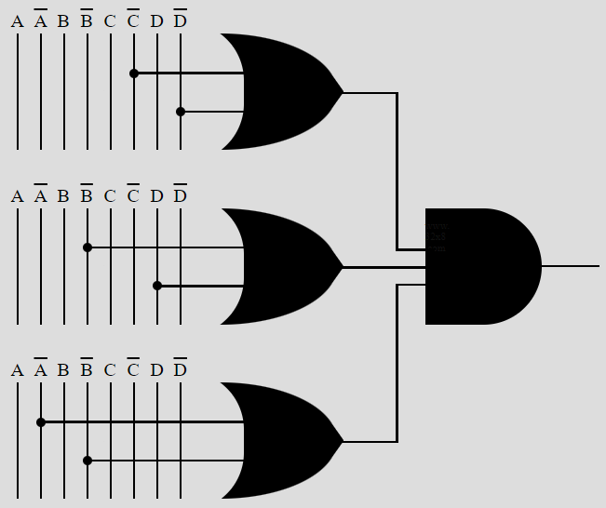

|  |  |  |  |  |  |
| --- | --- | --- | --- | --- | --- |
| **Truth Table** | | | | | |
|  | **A** | **B** | **C** | **D** | **F** |
| 0 | 0 | 0 | 0 | 0 | 1 |
| 1 | 0 | 0 | 0 | 1 | 1 |
| 2 | 0 | 0 | 1 | 0 | 1 |
| 3 | 0 | 0 | 1 | 1 | 0 |
| 4 | 0 | 1 | 0 | 0 | 0 |
| 5 | 0 | 1 | 0 | 1 | 1 |
| 6 | 0 | 1 | 1 | 0 | 0 |
| 7 | 0 | 1 | 1 | 1 | 0 |
| 8 | 1 | 0 | 0 | 0 | 1 |
| 9 | 1 | 0 | 0 | 1 | 1 |
| 10 | 1 | 0 | 1 | 0 | 1 |
| 11 | 1 | 0 | 1 | 1 | 0 |
| 12 | 1 | 1 | 0 | 0 | 0 |
| 13 | 1 | 1 | 0 | 1 | 0 |
| 14 | 1 | 1 | 1 | 0 | 0 |
| 15 | 1 | 1 | 1 | 1 | 0 |

**Task No. 2: Simplify the Boolean Function using K-Map: 𝐹 (𝐴, 𝐵, 𝐶, 𝐷) = ∑(1, 3, 7, 11, 15)**

**Which has the don’t care conditions: 𝐷 (𝐴, 𝐵, 𝐶, 𝐷) = ∑(0, 2, 5)**

**Verify Boolean function ‘F’ before and after K-Map simplification using truth table and design circuit on hardware / software.**

**SOLUTION:**

**K-MAP**

|  |  |  |  |  |
| --- | --- | --- | --- | --- |
|  | **C’. D’** | **C’. D** | **C. D** | **C. D’** |
| **A’.B’** | **X** | **1** | **1** | **X** |
| **A’.B** | **0** | **X** | **1** | **0** |
| **A.B** | **0** | **0** | **1** | **0** |
| **A.B’** | **0** | **0** | **1** | **0** |

**SUM OF PRODUCT**

|  |  |
| --- | --- |
| Groups | |
| (3,7,11,15) | C.D |
| (0,1,2,3) | A’.B’ |

**F = CD + A'B'**

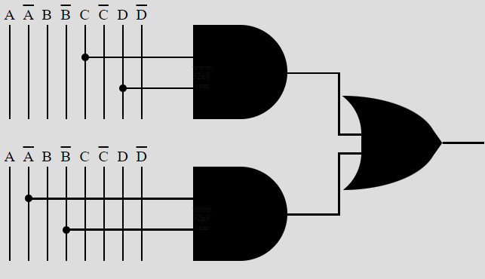

**PRODUCT OF SUM**

|  |  |
| --- | --- |
| Groups | |
| (0,2,4,6,8,10,12,14) | D’ |
| (8,9,12,13) | A’.C’ |

**F = D + A.C**

|  |  |  |
| --- | --- | --- |
| **F** | **=** | **D + A.C** |

**F = (D) (A' + C)**

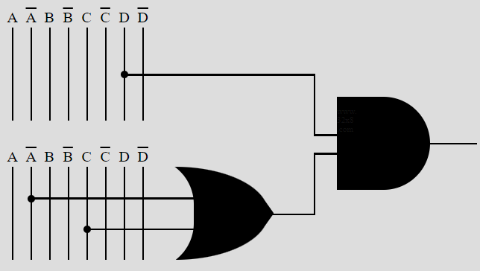

|  |  |  |  |  |  |
| --- | --- | --- | --- | --- | --- |
| Truth Table | | | | | |
|  | **A** | **B** | **C** | **D** | **F** |
| 0 | 0 | 0 | 0 | 0 | x |
| 1 | 0 | 0 | 0 | 1 | 1 |
| 2 | 0 | 0 | 1 | 0 | x |
| 3 | 0 | 0 | 1 | 1 | 1 |
| 4 | 0 | 1 | 0 | 0 | 0 |
| 5 | 0 | 1 | 0 | 1 | x |
| 6 | 0 | 1 | 1 | 0 | 0 |
| 7 | 0 | 1 | 1 | 1 | 1 |
| 8 | 1 | 0 | 0 | 0 | 0 |
| 9 | 1 | 0 | 0 | 1 | 0 |
| 10 | 1 | 0 | 1 | 0 | 0 |
| 11 | 1 | 0 | 1 | 1 | 1 |
| 12 | 1 | 1 | 0 | 0 | 0 |
| 13 | 1 | 1 | 0 | 1 | 0 |
| 14 | 1 | 1 | 1 | 0 | 0 |
| 15 | 1 | 1 | 1 | 1 | 1 |

**Task No. 3: Simplify the Boolean Function using K-Map: 𝐹 = 𝐸8 (Hex)**

**Verify Boolean function ‘F’ before and after K-Map simplification using truth table and design circuit on hardware / software.**

**SOLUTION:**

**if 𝐹 = 𝐸8 (hex), we can write this function in canonical form as: 𝐹 = Σ(0,1,2,3,8,9,10,11)**

**This indicates that the function 𝐹 is equal to the OR of minterms 0, 1, 2, 3, 8, 9, 10, and 11.**

**K-MAP**

|  |  |  |  |  |
| --- | --- | --- | --- | --- |
|  | **C’. D’** | **C’. D** | **C. D** | **C. D’** |
| **A’.B’** | **1** | **1** | **1** | **1** |
| **A’.B** | **0** | **0** | **0** | **0** |
| **A.B** | **0** | **0** | **0** | **0** |
| **A.B’** | **1** | **1** | **1** | **1** |

**SUM OF PRODUCT**

|  |  |
| --- | --- |
| Groups | |
| (0,1,2,3,8,9,10,11) | B’ |

**F = B'**

**PRODUCT OF SUM**

|  |  |
| --- | --- |
| Groups | |
| (4,5,6,7,12,13,14,15) | B |

**F = B**

|  |  |  |
| --- | --- | --- |
| **F** | **=** | **B** |

**F = (B')**

|  |  |  |  |  |  |
| --- | --- | --- | --- | --- | --- |
| Truth Table | | | | | |
|  | **A** | **B** | **C** | **D** | **F** |
| 0 | 0 | 0 | 0 | 0 | 1 |
| 1 | 0 | 0 | 0 | 1 | 1 |
| 2 | 0 | 0 | 1 | 0 | 1 |
| 3 | 0 | 0 | 1 | 1 | 1 |
| 4 | 0 | 1 | 0 | 0 | 0 |
| 5 | 0 | 1 | 0 | 1 | 0 |
| 6 | 0 | 1 | 1 | 0 | 0 |
| 7 | 0 | 1 | 1 | 1 | 0 |
| 8 | 1 | 0 | 0 | 0 | 1 |
| 9 | 1 | 0 | 0 | 1 | 1 |
| 10 | 1 | 0 | 1 | 0 | 1 |
| 11 | 1 | 0 | 1 | 1 | 1 |
| 12 | 1 | 1 | 0 | 0 | 0 |
| 13 | 1 | 1 | 0 | 1 | 0 |
| 14 | 1 | 1 | 1 | 0 | 0 |
| 15 | 1 | 1 | 1 | 1 | 0 |